Beacon Labs - Lab Report

Name: (Your name) | Date: (Date of lab completion)
Lab Name: (Name of the lab that was completed)

Setup:
(Description of the task and how you completed it. Include words and images as necessary)

Objective of this lab

Attacks on related subdomains have received limited attention within the research community, though pose a significantly additional power over traditional web attacks. An attacker can take control over sibling domains which provide the ability to abuse many territories of web application security, such as: cookies, CSP, CORS, postMessage, domain relaxation, and more. In this lab, we explore performing a subdomain takeover through the use of dangling DNS records, where subdomains reference empty third-party resources. Specifically, we will make use of Amazon’s DNS provider Route53 to host a set of targetable domains where we can perform real-world subdomain takeover attacks. Each subdomain will make use of a various set of external resources. This lab is based off of the paper \emph{Can I Take Your Subdomain? Exploring Same-Site Attacks in the Modern Web}, by M. Squarcina, M. Tempest, L. Veronese, S. Calzavara, and M. Maffei.

Task Set 1:
(Description of the task and how you completed it. Include words and images as necessary)

Task 1.1: Expected Utility Theory
Action 1.1.1
List the two lotteries you prefer the most (one from each pair) and give a simple written explanation as to why.
(Individual)

Action 1.1.2
Now that the format has changed, list the two lotteries you prefer the most (one from each pair) and give a simple explanation as to why. If your answer did not change, simply state so.
(Individual)

Task 1.2: Geometric Series
Action 1.2.1
What is the value of delta at which player 1 continues to uphold?

- 3 ≥ 2(1 - Δ) + Δ
- 3 ≥ 2 - 2Δ + Δ
- Δ ≥ -1

Task Set 2:
(Description of the task and how you completed it. Include words and images as necessary)

Task 2.1: Attack Surface Enumeration
Action 2.1.1
What is the IP address the DNS server associates with this domain?
(Answers will differ)
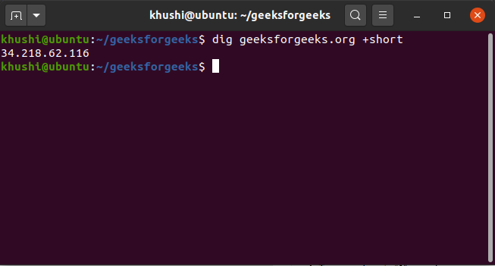
Action 2.1.2
What record is being resolved in Route53 under the subdomain foo.example.com?
CNAME

Action 2.1.3
What is the command you can use to run a DNS enumeration on a text file of domains?

python3 takeover.py -l domains.txt -v
Action 2.1.4
Run this command on the domains.txt file. This will provide an output of the potentially vulnerable domains and the associated services they use to operate. Submit a screenshot of this output.
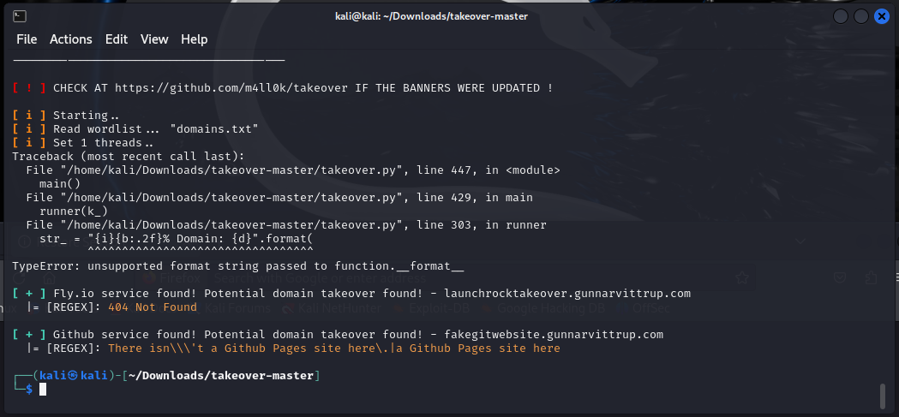

Action 2.1.5
List the name of the subdomain that you will attack and the service it utilizes.
(Individual)

Action 2.1.6
Run the command dig [domain] on the specific domain you have been provided. Submit a screenshot of the result.
(Answers will differ - should match Route53 record)
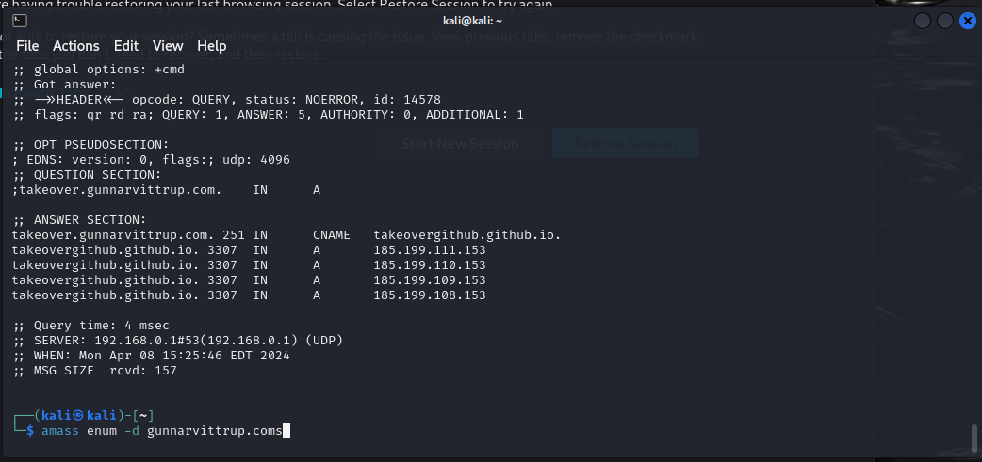

Action 2.2.1
Take over the subdomain listed in your previous answer and submit a screenshot of the page displaying the content within your index.html file.
